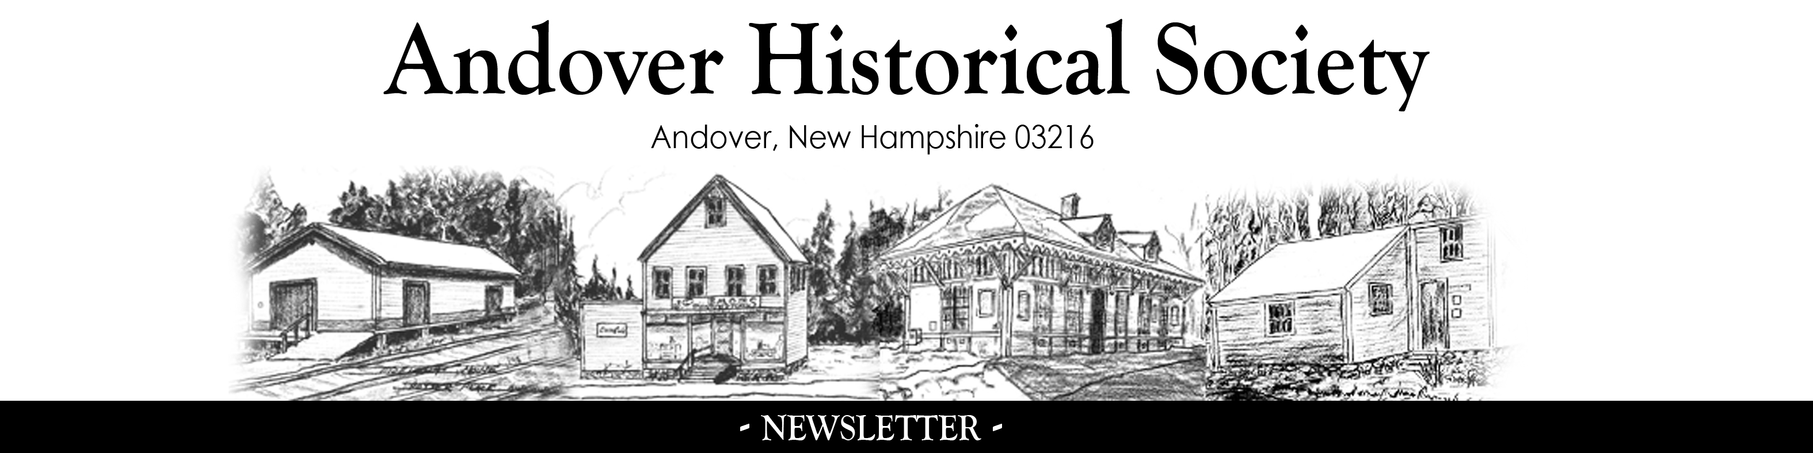

April 2015 Number 2

WHAT'S HAPPENING

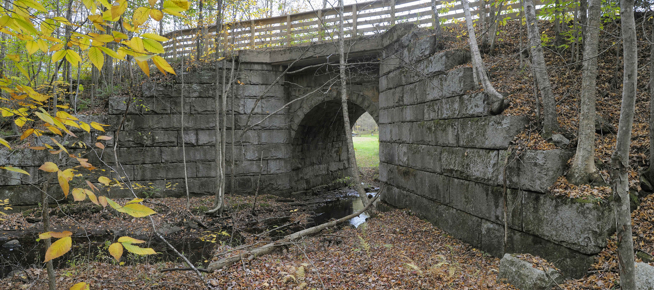
The Stone Arch Bridge in Danbury is only one of the 2100 architectural features photographed by Charley Freiberg along Northern Rail Trail between Boscawen to Lebanon. Some of those photographs will be the featured exhibit this year at the Potter Place RR Station. Charley is a commercial photographer who spent three months on this project.

COMMING EVENTS

Annual Clean Up Day - Saturday May 9th: HELP NEEDED starting at 9 am. The garden needs to cleaned of leaves and debris and the buildings and displays vacuumed and dusted. Bring your favorite rake or dust cloth.

The museum opens for the season on Saturday May 23rd. Volunteer stationmasters are always needed, between the hours of 10 to 3 on Saturdays, and 12:30 to 3 on Sundays. Two people are needed for each shift. on Many people who use the rail trail stop by with no clue as to what we have to offer. Meet new people and educate them about Andover and Potter Place. Some orientation will be necessary so contact Pat Cutter, 735-5628 or pres@andoverhistory.org. Give it a try.

The annual visit from the 4th grades in Andover, Salisbury and Webster is Wednesday June 3rd. Volunteers entertain the students with a game in the Emons Store, a visit to the caboose and the garden, history in the station, and lastly, an obstacle race.

On Friday June 5th the Society has agreed to conduct a class for OLLI (Osher Lifelong Learning Institure), an educational program for lifelong learners age 50+ run by Granite State College. The subject is Richard Potter and Potter Place and Dr. John Hodgson, a new year-round resident of Andover and an expert on Richard Potter has agreed to make a presentation as has Ken Cushing of Grafton who has spent many years researching the history of the Northern Railroad. Attendees will be supporters of OLLI and are paying tuition to attend.

The Tucker Mountain School will start it's 2015 schedule on Sunday June 14th and will be open on the 2nd Sunday of the month through October from 1to 3 pm.

On Thursday June 25th, our public meeting will be held at the HIghland Lake Grange Hall at 7 pm and will feature Jeff Warner a performer/interpreter of traditional music. Jeff was with us last year at the June meeting and was very well received. We are delighted to have him for a return engagement.

The Old Time Fair is Sunday August 2nd this year, from 9 to 2. All of the events will be as usual with music by Lindsay Schust and the Keasarge Mountain Band. We would be happy to take any of your lightly used items for the flea market and auction benefiting the Society. A call to Arch Weathers 735-5989, Pat Cutter 735-5628, Chris Norris 735-5120, Ed Hiller 735-5690 or Tim Norris 735-5369 will bring a fast response and pick up.

ANNUAL MEETING

October 15th is the date for the annual meeting and public program to be held at the East Highland Lake Grange Hall at 7 pm. Sharon & Steve Wood will entertain us with their presentation "Abraham & Mary Lincoln The Long & Short of It."

2016 CALENDAR: Then and Now in Andover Center

Our 2016 calendar will feature archival photographs of places in Andover Center along with a modern photo of the same place. Many changes have taken place. The generosity of our sponsors have made the annual calendar an important fundraiser for the Society. Thank you to all who have helped in previous years.

RAFFLE BASKET

Our basket-maker extraordinaire, Wanda Smith, has left us for Florida, but we hope that another genius will appear and our tradition will continue. Our local craftspeople and merchants have been very supportive and we know they will continue their interest. We need another fearless leader, and if we find her/him, tickets will be for sale on July 4 and the drawing will be at our fair on August 2nd.

SUPPORT

Dues are payable for 2015 and are a very important part of our income. Please remember to support your Society.

2015 MEMBERSHIP FORM
Membership Categories:
Andover Historical Society
PO Box 167
Andover, NH 03216 ⁪ Individual: $10.00 ⁪ Family: $25.00 ⁪ Donor: $50.00
⁪ Life Member: $200.00 per person ⁪ $350.00 per couple

⁪ Enclosed is a extra donation of ________________

Andover Historical Society is a 501 © (3) charitable organization
Please Print:
Name__________________________________________Email address______________________

Mailing Address______________________________________

City____________________________State___________Zip___________Tel. No.______________

Seasonal Mailing Address (please specify months)___________________________________________________________

Volunteers are always needed and welcomed. If you would like to participate in the work of the Andover Historical Society please indicate your special interest.

⁪ General Volunteer Work ⁪ Carpentry/Cabinet Work ⁪ Storage Space
⁪ Fund Raising ⁪ Photography ⁪ Special Projects
⁪ Programs ⁪ Public Relations ⁪ Gift of exhibition items
⁪ Clerical Work ⁪ Stationmaster ⁪ Other ___________
⁪ Grounds Maintenance ⁪ Display __________________
⁪ Building Maintenance ⁪ Computer Skills __________________

